**Big Mountain Ski Resort, Montana – Case Study**

The Ski and Snowboard Resorts industry is expected to continue growing at a higher rate over the five years to 2020. As per capita disposable income continues to increase, many Americans will likely continue spending on vacations and activities, such as skiing and snowboarding. IBISWorld anticipates industry revenue to increase at an annualized rate of 3.6% to $3.4 billion over the five years to 2020. Big Mountain Ski Resort suspects it may not be maximizing its returns, with respect to its position in the market. It also does not have a strong sense of facilities that are valuable to visitors. This data science project aims to build a predictive model for ticket price based on a number of facilities, or properties, boasted by resorts (at the resorts).

Figure 1

The data columns can be seen in the adjacent figure (Fig. 1). Two columns, namely 'fastEight' and 'AdultWeekday', were dropped as they were non-informative ( due to too many zero) and repetitive (similarity to 'AdultWeekend') data respectively.

**Features**

Target column was identified as 'AdultWeekday', i.e. 'Price'. Features were prepared as per four columns: TerrainParks, SkiableTerrain_ac, daysOpenLastYear and NightSkiing_ac. According to Wikipedia demographics, they were aggregated per sum and added as new columns (see fig. 2).

Figure 2

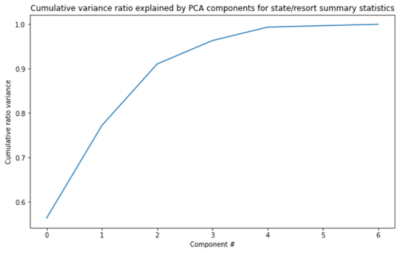6 out of the 7 newly created features dominate 75% of the variance (see fig. 3). In order to see the correlation two dataset were merged into a single dataset. Most significant correlation were observed with fastQuads, Runs and Snow Making_ac. It turns out that the visitors would seem to value more guaranteed snow, which would cost in terms of snow making equipment, which would drive prices and costs up.

Figure 3

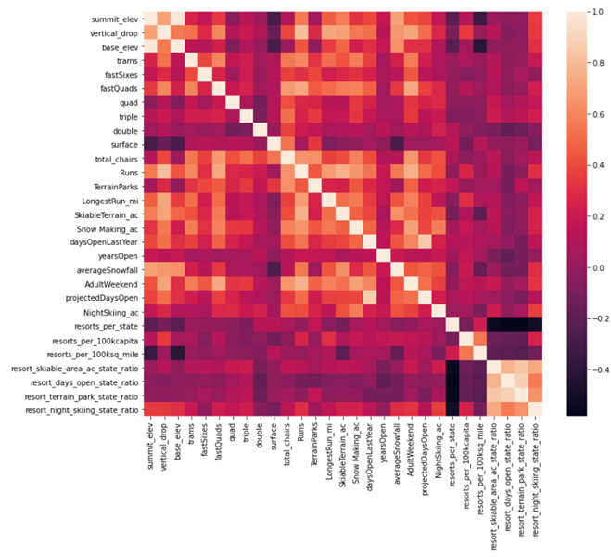

Figure 4

**Fitting and Predicting**

Of the new features created, resort_night_skiing_state_ratio seems to have a mild correlation. This also could be considered as a subject for incremental investment. First, R-squared value is examined per mean of the target, 0.7-to-0.8 looks promising. Comparison by both median and mean were applied for modelling and the former favored a slightly more over the later. The whole data is scaled by StandardScaler, imputed with median, as well as mean. Train/Test split of 70%/30% (which was validated by learning_curve later). Pipes were created for both linear regression and random regressor, where the latter is performed better. Cross validation was highly variable, best_params was applied and gave only 8 features. Random regressor parameters were reset, and iterated again, the final MAE was obtained as 10.1.

Figure 5

Figure 6

**Suggested improvements**

Two possibilities exist: (1) predicting a price increase/decrease, (2) cost saving by reducing the features. The best model was applied, and it observed that Big Mountain Resort modelled price is 93.77 USD, where actual price is 81.00 USD. The expected mean absolute error of 10.21 USD suggests there is room for an increase. 5 USD increase may result in a total of 7.5M USD (350K guests per 5 days stay in average) per year. As far as cost saving is concerned, several change proposals were noted. Adding a run, increasing the vertical drop by 150 feet, and installing an additional chair lift; 1.99 USD increase that may sum 3.5M USD per year. (Adding 2 acres of snow making on top of this does not look like having incremental effect.) Close up to 10 of the least used runs -> Very slight price decrease with up to 6 (excluding) close ups, which makes it very much applicable.

**Future directions**

There is lack of information provided around the costs: Closing runs may have other benefits like decreasing the costs, other than the ticket price which is the primary target. Moreover, when the length of the run is increased, we're having some gain with the pricing, however this is not a net value, since we don't know the size of the investment we need for the extra chairs.